Border Town Burning Scenarios

# General Rules

## Table

All scenarios are played on a 4x4’ (feet) table, unless stated otherwise.

## Ending the Game

All scenarios end, when all but one warbands have routed (either voluntarily or by an unfortunate roll). If the scenario has additional Game-ending conditions, they are noted at the scenario.

## Setting up the game

If not stated otherwise, all players roll a D6. The players then pick a table edge in the order of the dice rolls, starting with the highest roll. The warbands must be places within 8” of that table edge.

If not stated otherwise, players start on opposite table edges in non-multiplayer scenarios.

## Starting the game

All players roll a D6. The player who rolls the highest goes first. Starting with that player the turn order is clockwise of their seating.

## Territory

Each scenario is set in one of the Border Town Burning territories.

# Avalanche!

## Territory

Northern Wastes

## Special Rules

**Giant Avalanche**: At random determine one of the two "unused" board edges after both players have deployed their warbands. After the second player's turn the avalanche moves 2D6" forward.

A model buried by the avalanche is immediately taken out of action (see special rule Buried). The area buried by the avalanche counts as impassable terrain.

**Triggers**: Every time a blackpowder weapon, fire bomb, explosive or fire ball is used, roll a D6:

on a score of 6 an avalanche is triggered. When a cannon is fired, like the Pirates' swivel cannon, add +2 to the roll. An avalanche can also be triggered by the following skills:

Bellowing Roar (Beastmen or Maneaters) and Bellowing Battle Roar (Lizardmen).

When a new avalanche is triggered, determine a random edge of a board that represents the foot of the mountain. In some scenarios there may be given sides where an avalanche can come from – in that case, randomly determine one of them.

**Buried**: After the battle roll a D6 for each Hero and Henchman taken out of action by an avalanche. On a roll of 1 the warrior that was buried is dead. Remove him from the warband’s roster.

## Ending the Game

The game ends in a tie when the avalanche reaches to being within 8" or less away from its opposing board edge – or in other words it has buried the whole board except for an area of 4' x 8".

## Experience

**+1 Survives**. If a Hero or Henchman group survives the battle they gain +1 Experience.

**+1 Winning Leader**. The leader of the winning warband gains +1 extra Experience.

+**1 Per Enemy Out of Action**. Any Hero earns +1 Experience for each enemy he puts out of action.

# Horrors of the Underground

## Territory

This underground scenario uses 20 special 8” x 8” floor tiles.

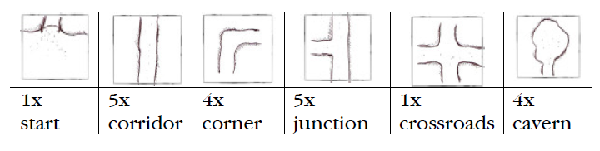

Use the start tile, a corridor tile, a junction and a crossroads to create the opening configuration as depicted below.

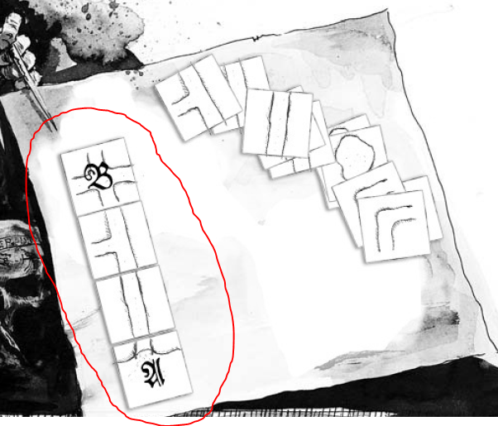

## Setting up the game

The attacking warband starts at the entrance to the tunnel on the start tile (see position A). The defending warband deploys on the crossroads tile (see position B). Note that caverns are effectively dead-ends.

## Starting the game

The defending player takes the first turn.

## Special Rules

**Going underground**: Any ridden animals and wagons of either warband miss this battle.

**Tools**: All warband members capable of using equipment may get a free torch at the beginning of the game. In addition, all models using bows get free fire arrows for this game. These items can be used in this game only and are lost after the battle.

**Unexplored**: A floor tile with path edges that have no adjacent tile yet placed counts as unexplored area. Models may not run when crossing into an unexplored tile.

**Exploring tunnels**: When a model moves into base contact with the edge of a floor tile with no adjacent tile yet placed, determine at random which floor tile is placed there. In the case of corners and junctions, the player whose model explored this part of the mine gets to choose how the new tile is placed. After each tile is placed, roll 2D6 on the following table to determine whether anything special happens:

|  |  |
| --- | --- |
| Dice roll (2D6) | Effect |
| 2 | **Tunnel collapse** |
| 3 – 4 | **Wyrm!** The wyrm appears. |
| 5 | **Spiders**: Place D3 Giant Spiders on the tile. |
| 6 | **Rats**: Place D3 Giant Rats on the tile. |
| 7 | **Nothing happens** |
| 8 – 9 | **Powder Kegs**: Place D3 powder kegs anywhere on the floor tile. |
| 10 – 11 | **The Egg!** You found the Wyrm’s Egg! Place a marker for the egg anywhere on the floor tile. Any hero may move into contact with the egg and skip the rest of his turn to pick it up. |
| 12 | **Exit!**  Place a dungeon door marker alongside the floor tile. Any model that moves into base contact with the marker counts as having moved off the board. |

**Tunnel collapse**: Place a marker directly before the exploring model to indicate this route has been blocked off. The block can be cleared by non-animal models. This is represented by attacking the barrage of boulders in the close combat phase (Toughness 6, Wounds 4). The barrage has a 3+ armor save that is affected as usual by Strength modifiers.

**The Wyrm’s Egg**: Whenever a model that carries a Wyrm Egg enters an unexplored area treat all results of 3-6 as the effect for Wyrm! In addition, whenever the model enters a previously explored tile, roll a D6: on 1-2 the Wyrm appears. The Egg is worth D6x10 gold crowns when taken off the board. Alternatively, instead of selling the egg the player may choose to crack open the egg shell and roll on the following table to see what it contains:

|  |  |
| --- | --- |
| Dice roll (2D6) | Effect |
| 2 – 7 | **Nothing** |
| 8 – 10 | **Young Wyrm:** A spell-user may use the young animal as a Familiar (see Mordheim Annual 2002, p. 61). Alternatively can be sold for D6x10 GC. |
| 11 – 12 | **Artefact**: Roll on the Lesser Artefacts table to see what the egg contained. |

**The Wyrm**:

|  |  |  |  |  |  |  |  |  |  |  |
| --- | --- | --- | --- | --- | --- | --- | --- | --- | --- | --- |
| Profile | M | WS | BS | S | T | W | I | A | LD | AS |
| Wyrm | 6 | 4 | - | 6 | 5 | * | 5 | 3 | 9 | 5+ |

**Causes Fear!**

*: Whenever a model causes the Wyrm to lose a Wound, the monster digs a way out of the tunnel and disappears. Remove the Wyrm from the game. It will reappear as soon as the Wyrm event is rolled again.

## Ending the Game

The warband who manages to take the Wyrm’s egg off the board wins the game. If the game ends before (by routing) any eggs in possession of any warband count as recovered.

## Experience

**+1 Survives**. If a Hero or Henchman group survives the battle they gain +1 Experience.

**+1 Winning Leader**. The leader of the winning warband gains +1 extra Experience.

**+1 Per Enemy Out of Action**. Any Hero earns +1 Experience for each enemy he puts out of action.

**+D3+1 for the Wyrm’s Egg.** The warband that manages to take a Wyrm’s Egg off the board may distribute D3+1 Experience freely among the warbands heroes.

# Unlocking the Tomb

## Terrain

There should be at least 7 buildings and a large (10x10“) building (room) in the center of the table.

That building is considered “The Tomb”. The Tomb has exactly one entrance and can only be entered once the entrance is opened with the key.

## Territory

Cathayan Borderlands

## Setting up

Additional to the basic rules, neither player may set up a warrior within 15" of the tomb entrance.

## Ending the Game

Additionally the game ends, when the last remaining hero of a warband leaves the game with a treasure box.

## Special Rules

The Main Objective for all warbands is to find the key (there is exactly one key, no more no less). Therefore they have to search all buildings on the table (move a least one hero [henchmen cannot find the key] within 1” of the building to search).

Only heroes unengaged, he may elect to search the room to the exclusion of everything else (like shooting a missile weapon). When a hero searches, roll a D6. On a roll of 6, the key is found.

Each building may only be searched once.

If a warrior carrying the key is stunned or put OOA, then any warrior in base contact may retrieve the key from that warrior, provided that there are no enemy models within 2" of the downed warrior. A hero cannot drop the key or pass it on unless he is OOA or stunned.

If all rooms have been searched by each warband, the key was “under the mat” all the time. The first hero to reach the door to the Tomb can open it automatically.

Each hero that enters the Tomb may search for treasure (as before, skipping everything else) gaining a treasure box.

## Rewards

Every hero leaving the table with a treasure box may roll 2D6, while the first two heroes **may** alter their roll by ± 1.

|  |  |
| --- | --- |
| Dice roll (2D6) | Reward |
| 2 – 5 | Nothing |
| 6 – 7 | D6 GC |
| 8 | D6 + 1 GC |
| 9 | 2D6 GC |
| 10 | Tarriks Medallion of Office  - Dwarfs: The Warband leader gains +D6” to the range of his **Leader** ability (note on the roster).  - All other warbands (except Undead/Possessed): may sell the medallion for 2D6+2 GC |
| 11 | Tarriks Flask – Roll a D6 before each battle. On 1-2, the flask produces one dose of Tears of Shallya. That dose has to be used in the battle or vanishes (and cannot be sold).  Can be sold for 3D6 GC. |
| 12 | Tarriks Sceptre – Counts as a magic mace with the following special rules: Any hits against undead cause two wounds, not one. Each wound may be saved separately. Counts as a Holy Relic for Dwarf Warbands.  Can be sold for 3D6+2 GC. |

## Experience

**+1 Survives**. If a Hero or Henchman group survives the battle they gain +1 Experience.

**+1 Winning Leader**. The leader of the winning warband gains +1 extra Experience.

+**1 Per Enemy Out of Action**. Any Hero earns +1 Experience for each enemy he puts out of action.

**+1 Opens the Tomb**. The hero who opens the tomb gains +1 extra Experience.

**+1 Destroys Artefact**. If an Undead or Possessed warband recovers one of Tarriks artefacts (Medallion of Office, Flask or Sceptre) the warbands leader destroys it and gains +1 extra experience.